**INDEX**

| **Exp. No** | **Date** | **Experiment Name** | **Page No** | **Marks** | **Signature** |
| --- | --- | --- | --- | --- | --- |
| 1 | 20.01.21 | SEQUENTIAL PROGRAMMING | 04-06 |  |  |
| 2a | 27.01.21 | DECISION MAKING USING IF ELSE LADDER | 07-12 |  |  |
| 2b | 03.02.21 | DECISION MAKING USING SWITCH CASE | 13-19 |  |  |
| 3 | 10.02.21 | LOOPING | 20-25 |  |  |
| 4 | 18.02.21 | NESTED FOR LOOP | 26-28 |  |  |
| 5 | 24.02.21 | 1D ARRAY | 29-33 |  |  |
| 6 | 03.03.21 | 2D ARRAY | 34-36 |  |  |
| 7 | 17.03.21 | POINTERS | 37-40 |  |  |
| 8 | 22.03.21 | USER DEFINED FUNCTION | 41-44 |  |  |
| 9 | 22.03.21 | STRUCTURES | 45-48 |  |  |
| 10 | 22.03.21 | FILES | 49-53 |  |  |

## Ex.No :1 Date:

**SEQUENTIAL PROGRAMMING**

**PROBLEM GIVEN**: Write a program to store the following details - Customer ID, Age,Customer type ( Regular - R and Temporary - T),Medicine Id, quantity of medicine to be purchased. Declare variables of appropriate data types, read the values from the user and calculate the final bill based on the quantity of purchase made, add GST of 5% to the total amount. Display the customer bill with all the necessary information.

## ALGORITHM:

## Cust _id =customer id

## Custage = customer age

## Medid = medicine id

## Quant = quantity of medicine

## cust_type = customer type regular or temporary

## pcs_amt = price of one medicine

## price = to store the total price of medicine

## gst = to add 5% fixed gst to price

## tot_amt = to store the total price after adding gst

## STEP-1 = START

## STEP-2 = Input value of custid , custage , cust_type , medid , quant , pcs_amt , price , gst , tot_amt

## STEP-3 = price = quant*pcs_amt gst = price*0.05

## tot_amt = price+gst STEP-4= Display tot_amt

## STEP-5= STOP

## FLOW CHART:

## PROGRAM:

## #include <stdio.h>

## #include <conio.h>

## #include <string.h>

## int first=5,second=5;

## void regular()

## {

## int custid,custage,medid,quant;

## float pcs_amt,price,Tot_amt,gst; printf("Input Customer ID :\n");

## scanf(" %d",&custid);

## printf("Input Customer Age : \n");

## scanf(" %d",&custage);

## printf("Input the medicine ID : \n");

## scanf(" %d",&medid);

## printf("enter the quantity :\n ");

## scanf(" %d",&quant);

## printf("enter the amount of 1medicine : \n");

## scanf(" %f",&pcs_amt);

## price=quant*pcs_amt;

## gst=price*0.05;

## Tot_amt=price+gst;

## printf("Customer ID: %d\n",custid); printf("Customer age: %d\n",custage);

## printf("medicine ID: %d\n",medid); printf("quantity: %d\n",quant); printf("amount of 1 medicine: %f\n",pcs_amt);

## printf("price: %f\n",price);

## printf("total amount: %f\n",Tot_amt); }

## void temporary()

## {

## int custid,custage,medid,quant; float pcs_amt,price,Tot_amt,gst; printf("Input Customer ID :\n"); scanf(" %d",&custid);

## printf("Input Customer Age : \n"); scanf(" %d",&custage);

## printf("Input the medicine ID : \n");

## scanf(" %d",&medid);

## printf("enter the quantity :\n ");

## 

## scanf(" %d",&quant);

## printf("enter the amount of 1medicine : \n");

## scanf(" %f",&pcs_amt);

## price=quant*pcs_amt;

## gst=price*0.05;

## Tot_amt=price+gst;

## printf("Customer ID: %d\n",custid); printf("Customer age: %d\n",custage);

## printf("medicine ID: %d\n",medid);

## printf("quantity: %d\n",quant);

## printf("amount of 1 medicine: %f\n",pcs_amt); printf("price: %f\n",price);

## printf("total amount: %f\n",Tot_amt); }

## void main()

## {

## int n;

## printf("Pharmacy management(MDS) \n Enter Customer type \n"); printf("1.R:regular\n2.T:temporary \nenter your option:"); scanf("%d",&n);

## switch(n)

## {

## case 1: regular();

## break;

## case 2: temporary();

## break; default:

## break; }

## getch();

## }

**OUTPUT:**

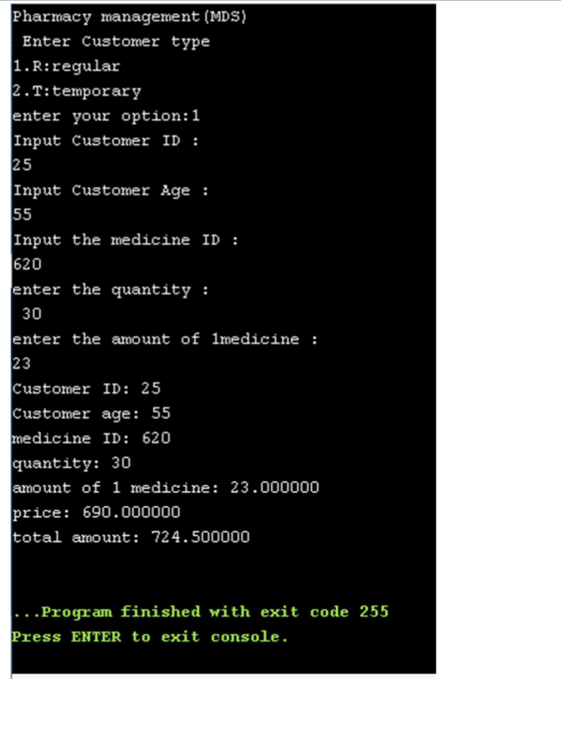

## Ex.No :2a Date:

**DECISION MAKING USING IF ELSE LADDER**

**PROBLEM GIVEN**: Write the program to generate the customer bill based on the following 1. Discount of 10% for regular customers. 2. Based on the Medicine name (P - paracetamol Rs 5/tab, L - Levocitrizine Rs2/tab R - Rantac Rs2/tab A - Amoxicillin Rs 10/tab) fix the rate of the tablet accordingly (Read the medicine name from the user and store it in a variable). (extend the previous program to implement the above) Display the customer medical bill with all the necessary information.

## ALGORITHM:

## Cust_id = customer id

## Custage =customer age

## Medid = medicine id

## cust_type = customer type regular or temporary

## pcs_amt = price of one medicine

## price = total price of all medicine

## gst = to add 5% gst

## tot_amt. = to store total price after adding gst.

## medicine_to_purchased= to store the medicine to be purchased.

## paracetamol_quantity= to store the quantity of paracetamol tablet

## levocitrizine_quantity= to store the quantity of levocitrizine tablet

## rantac_quantity= to store the quantity of rantac tablet

## amoxicillin_quantity= to store the quantity of amoxicillin tablet

## paracetamol_rate= fixed price of paracetamol tablet

## levocitrizine_rate= fixed price of levocitrizine tablet

## rantac_rate= fixed price of rantac tablet

## amoxicillin_rate= fixed price of amoxicillin tablet medicine_purchased= to the medicine purchased by customer price_discount= to calculate 10% discount of regular customer

## STEP-1 = START

## STEP-2 = Input value o custage , cust_type , medid , pcs_amt ,

## medicine_to_purchased, paracetamol_quantity, levocitrizine_quantity, rantac_quantity, amoxicillin_quantity, paracetamol_ rate, levocitrizine_ rate, rantac_ rate,

## amoxicillin_ rate, medicine_purchased,

## STEP-3 = price = c+d+e+f

## gst = price*0.05

## price_discount= (price*10)/100

## tot_amt = price+gst-price_discount  STEP-4= Display tot_amt

## STEP-5= STOP

## 

## FLOW CHART:

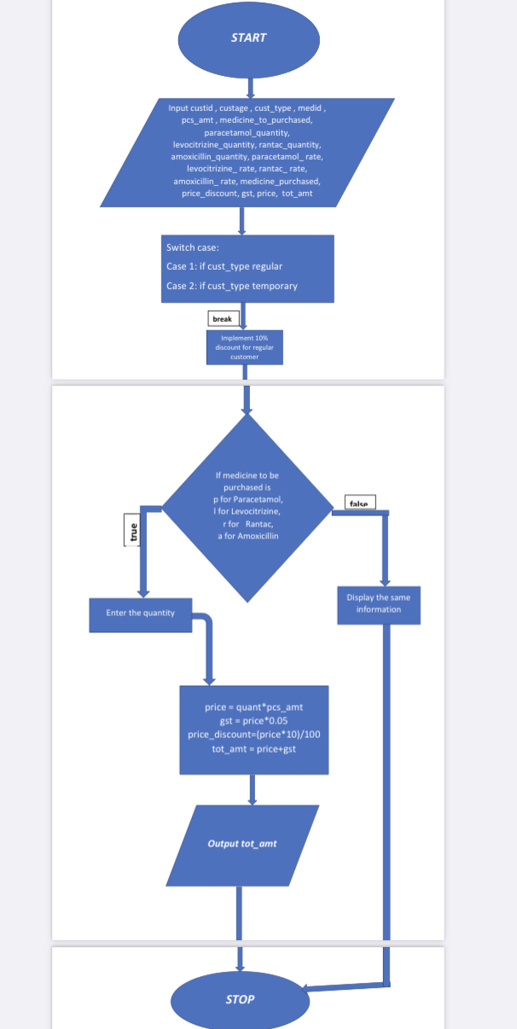

## PROGRAM:

## 

**#include <stdio.h>**

**#include <conio.h>**

**#include <string.h>**

**#include <math.h>**

**int first=5,second=5;**

**void regular()**

**{**

**int custid,custage,medicine_to_purchase,i; int**

**paracetamol_quantity,levocitrizine_quantity,rantac_quantity,amoxicillin_quan tity;**

**float paracetamol_rate = 5;// this rate is based per tablet float levocitrizine_rate = 2;// this rate is based per tablet float rantac_rate = 2;// this rate is based per tablet**

**float amoxicillin_rate = 10;// this rate is based per tablet float price,gst,Tot_amt,price_discount;**

**char medicine_purchased[50]; float c,d,e,f;**

**printf("Input Customer ID :\n"); scanf(" %d",&custid); printf("Input Customer Age : \n"); scanf(" %d",&custage);**

**printf("enter number of medicine to purchase \n"); scanf("%d",&medicine_to_purchase);**

**for ( i = 0; i < medicine_to_purchase; i++) {**

**printf("what do you want to purchase p for Paracetamol, l for Levocitrizine,r for Rantac,a for Amoxicillin \n");**

**scanf("%s",medicine_purchased);**

**if ((strcmp(medicine_purchased,"p") ==**

**0)||(strcmp(medicine_purchased,"P") == 0))**

**{**

**printf("Input the paracetamol medicine ID :15 \n"); printf("how many Paracetamol tablets u want: \n"); scanf("%d",&paracetamol_quantity); c=paracetamol_rate*paracetamol_quantity;**

**}**

**else if ((strcmp(medicine_purchased,"l") == 0)||(strcmp(medicine_purchased,"L") == 0))**

**{**

**printf("Input the levocitrizine medicine ID :20 \n"); printf("how many Levocitrizine tablets u want: \n"); scanf("%d",&levocitrizine_quantity); d=levocitrizine_rate*levocitrizine_quantity;**

**}**

**else if ((strcmp(medicine_purchased,"r") ==**

**0)||(strcmp(medicine_purchased,"R") == 0)) {**

**printf("Input the rantac medicine ID :25 \n"); printf("how many Rantac tablets u want: \n"); scanf("%d",&rantac_quantity); e=rantac_rate*rantac_quantity;**

**}**

**else if ((strcmp(medicine_purchased,"a") ==**

**0)||(strcmp(medicine_purchased,"A") == 0)) {**

**printf("Input the amoxicillin medicine ID :30 \n"); printf("how many Amoxicillin tablets u want: \n"); scanf("%d",&amoxicillin_quantity); f=amoxicillin_rate*amoxicillin_quantity;**

**}**

**}**

**price= c+d+e+f;**

**gst=price*0.05; price_discount=(price*10)/100; Tot_amt=price-price_discount+gst;**

**printf("Customer ID: %d\n",custid); printf("Customer age: %d\n",custage); printf("price: %f\n",price);**

**printf("gst: %f\n",gst);**

**printf("price_discount: %f\n",price_discount); printf("total amount: %f\n",Tot_amt);**

**}**

**void temporary() {**

**int custid,custage,medicine_to_purchase,i;**

**int paracetamol_quantity,levocitrizine_quantity,rantac_quantity,amoxicillin_quan tity;**

**float paracetamol_rate = 5;// this rate is based per tablet float levocitrizine_rate = 2;// this rate is based per tablet float rantac_rate = 2;// this rate is based per tablet**

**float amoxicillin_rate = 10;// this rate is based per tablet float price,gst,Tot_amt;**

**char medicine_purchased[50]; float c,d,e,f;**

**printf("Input Customer ID :\n");**

**scanf(" %d",&custid);**

**printf("Input Customer Age : \n");**

**scanf(" %d",&custage);**

**printf("enter number of medicine to purchase \n"); scanf("%d",&medicine_to_purchase);**

**for ( i = 0; i < medicine_to_purchase; i++) {**

**printf("what do you want to purchase p for Paracetamol, l for Levocitrizine,r for Rantac,a for Amoxicillin \n");**

**scanf("%s",medicine_purchased);**

**if ((strcmp(medicine_purchased,"p") == 0)||(strcmp(medicine_purchased,"P") == 0))**

**{**

**printf("Input the paracetamol medicine ID :15 \n");**

**printf("how many Paracetamol tablets u want: \n"); scanf("%d",&paracetamol_quantity); c=paracetamol_rate*paracetamol_quantity;**

**}**

**else if ((strcmp(medicine_purchased,"l") == 0)||(strcmp(medicine_purchased,"L") == 0))**

**{**

**printf("Input the levocitrizine medicine ID :20 \n"); printf("how many Levocitrizine tablets u want: \n"); scanf("%d",&levocitrizine_quantity);**

**d=levocitrizine_rate*levocitrizine_quantity; }**

**else if ((strcmp(medicine_purchased,"r") == 0)||(strcmp(medicine_purchased,"R") == 0))**

**{**

**printf("Input the rantac medicine ID :25 \n"); printf("how many Rantac tablets u want: \n"); scanf("%d",&rantac_quantity);**

**e=rantac_rate*rantac_quantity; }**

**else if ((strcmp(medicine_purchased,"a") == 0)||(strcmp(medicine_purchased,"A") == 0))**

**{**

**printf("Input the amoxicillin medicine ID :30 \n"); printf("how many Amoxicillin tablets u want: \n"); scanf("%d",&amoxicillin_quantity);**

**f=amoxicillin_rate*amoxicillin_quantity; }**

**}**

**price=c+d+e+f; gst=price*0.05; Tot_amt=price+gst;**

**printf("Customer ID: %d\n",custid); printf("Customer age: %d\n",custage); printf("price: %f\n",price);**

**printf("gst: %f\n",gst);**

**printf("total amount: %f\n",Tot_amt);**

**}**

**void main()**

**{**

**int n;**

**printf("Pharmacy management(MDS) \nEnter Customer type \n"); printf("1.R-regular-10percent discount\n2.T-temporary \nEnter your option:"); scanf("%d",&n);**

**switch(n)**

**{**

**case 1: regular();**

**break;**

**case 2: temporary();**

**break; default:**

**break; }**

**getch();**

**}**

**OUTPUT :**

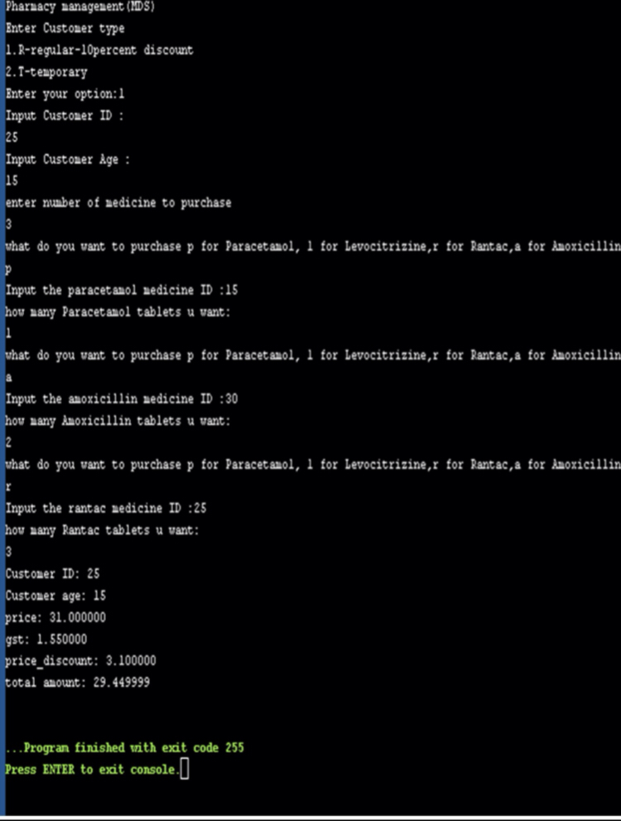

## Ex.No :2b Date:

**DECISION MAKING USING SWITCH CASE**

**PROBLEM GIVEN**: write a program to display menu 1. Customer details 2. Customer bill 3. Exit, Based on the input selection by the user appropriate actions needs to taken care. Use previous program and extend it.

## ALGORITHM:

## Cust_id = customer id

## Custage = customer age

## Medid = medicine id

## cust_type = customer type regular or temporary

## price = to store the price one medicine

## gst = to add gst

## tot_amt = to store total amount after adding gst

## medicine_to_purchased= to store the medicine to be purchased. paracetamol_quantity= to store the quantity of paracetamol tablet levocitrizine_quantity= to store the quantity of levocitrizine tablet rantac_quantity= to store the quantity of rantac tablet

## amoxicillin_quantity= to store the quantity of amoxicillin tablet paracetamol_rate= fixed price of paracetamol tablet

## levocitrizine_rate= fixed price of levocitrizine tablet

## rantac_rate= fixed price of rantac tablet

## amoxicillin_rate= fixed price of amoxicillin tablet medicine_purchased= to the medicine purchased by customer price_discount= to calculate 10% discount of regular customer

## STEP-1 = START

## STEP-2 = Enter the value of custid ,custage

## STEP-3 = Enter cust_type reg for Regular and temp for Temporary STEP-4 = what type of medicine want to purchased

## what do you want to purchase p for Paracetamol, l for Levocitrizine,

## r for Rantac,a for Amoxicillin.

## STEP-5=Enter the quantity of tablets you to purchase as per medicine selection

## STEP-6 = for regular (10% discount)

## price = c+d+e+f

## gst = price*0.05

## price_discount= (price*10)/100 tot_amt = price+gst-price_discount

## STEP-7= for temporary

## price = c+d+e+f

## gst = price*0.05

## tot_amt = price+gst-price_discount STEP-8= switch(a)

## case 1: customer details; case 2: customer bill;

## case 3: Exit;

## STEP-9= Display information as per case selection

## STEP-10= STOP

**FLOWCHART:**

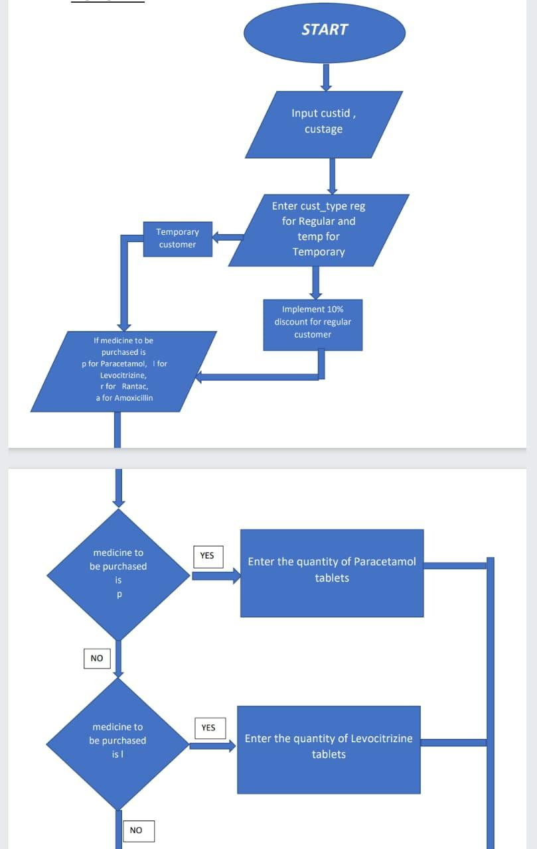

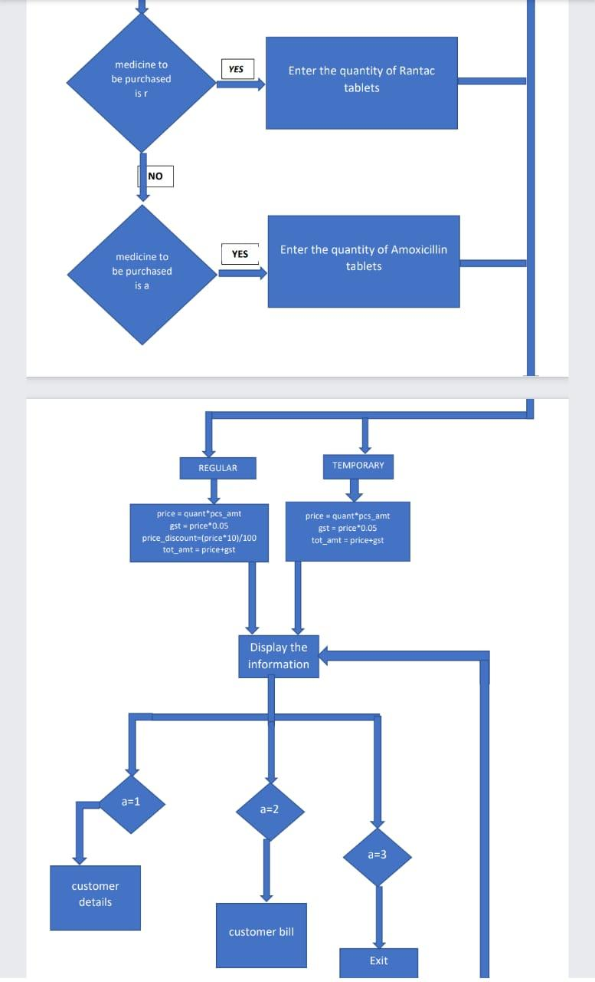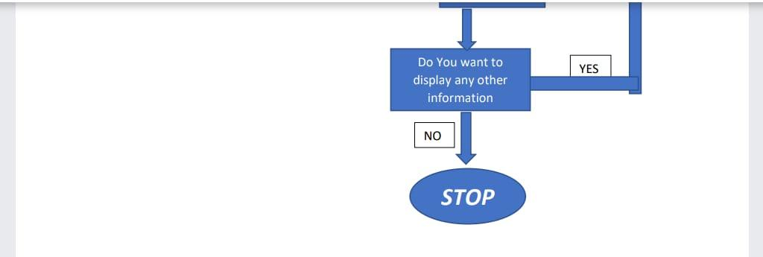

**PROGRAM :**

**#include <stdio.h>  
#include <conio.h>  
#include <string.h>  
#include <math.h>  
void main()  
{   
 int custid,custage,medicine_to_purchase,i,a,h;  
 int paracetamol_quantity,levocitrizine_quantity,rantac_quantity,amoxicillin_quantity;  
 float paracetamol_rate = 5;// this rate is based per tablet   
 float levocitrizine_rate = 2;// this rate is based per tablet  
 float rantac_rate = 2;// this rate is based per tablet  
 float amoxicillin_rate = 10;// this rate is based per tablet  
 float price,gst,Tot_amt,price_discount;  
 char medicine_purchased[50];  
 char cust_type[50];  
 float c,d,e,f;  
 char opt[50];  
 printf("Input Customer ID :\n");  
 scanf(" %d",&custid);  
 printf("Input Customer Age : \n");  
 scanf(" %d",&custage);  
 printf("enter customer type reg for regular temp for temporary \n");  
 scanf("%s",&cust_type);  
 printf("enter number of medicine to purchase \n");  
 scanf("%d",&medicine_to_purchase);  
for ( i = 0; i < medicine_to_purchase; i++)  
{  
 printf("what do you want to purchase p for Paracetamol, l for Levocitrizine,r for Rantac,a for Amoxicillin \n");  
 scanf("%s",medicine_purchased);  
 if ((strcmp(medicine_purchased,"p") == 0)||(strcmp(medicine_purchased,"P") == 0))  
 {  
 printf("Input the paracetamol medicine ID :15 \n");  
 printf("how many Paracetamol tablets u want: \n");  
 scanf("%d",&paracetamol_quantity);   
 c=paracetamol_rate*paracetamol_quantity;  
 }**

**else if ((strcmp(medicine_purchased,"l") == 0)||(strcmp(medicine_purchased,"L") == 0))**

**{  
 printf("Input the levocitrizine medicine ID :20 \n");  
 printf("how many Levocitrizine tablets u want: \n");  
 scanf("%d",&levocitrizine_quantity);   
 d=levocitrizine_rate*levocitrizine_quantity;  
 }**

**if ((strcmp(medicine_purchased,"r") == 0)||(strcmp(medicine_purchased,"R") == 0))**

**{  
 printf("Input the rantac medicine ID :25 \n");  
 printf("how many Rantac tablets u want: \n");  
 scanf("%d",&rantac_quantity);  
 e=rantac_rate*rantac_quantity;   
 }**

**else if((strcmp(medicine_purchased,"a") == 0)||(strcmp(medicine_purchased,"A") == 0))**

**{  
 printf("Input the amoxicillin medicine ID :30 \n");  
 printf("how many Amoxicillin tablets u want: \n");  
 scanf("%d",&amoxicillin_quantity);   
 f=amoxicillin_rate*amoxicillin_quantity;   
 }**

**}**

**if (strcmp(cust_type,"reg") == 0 || strcmp(cust_type,"REG"))**

**{**

**price= c+d+e+f;  
 gst=price*0.05;  
 price_discount=(price*10)/100;  
 Tot_amt=price-price_discount+gst;  
}**

**else if (strcmp(cust_type,"temp") == 0 || strcmp(cust_type, "TEMP"))**

**{**

**price=c+d+e+f;  
 gst=price*0.05;**

**Tot_amt=price+gst;**

**}**

**do**

**{**

**printf("enter what you want to be displayed \n 1.for customer details\n 2.customer bill \n 3.EXIT\n");  
 scanf("%d",&a);  
 switch (a)**

**{**

**case 1:  
 printf("Customer ID: %d\n",custid);  
 printf("Customer age: %d\n",custage);  
 printf("customer type : %s\n", cust_type);  
 break;  
 case 2:  
 printf("your gst is : %f\n",gst);  
 printf("price_discount: %f\n",price_discount);  
 printf("your total bill is : %f\n",Tot_amt);  
 break;  
 case 3:  
 printf("do you want to display any other information yes or no \n");  
 scanf("%s",&opt);  
 if (strcmp(opt,"yes") == 0||strcmp(opt,"YES") ==0)  
 {  
 h=1;  
 }  
 else  
 {  
 h=0;  
 }  
 }**

**} while (h>0);**

**getch();**

**OUTPUT:**

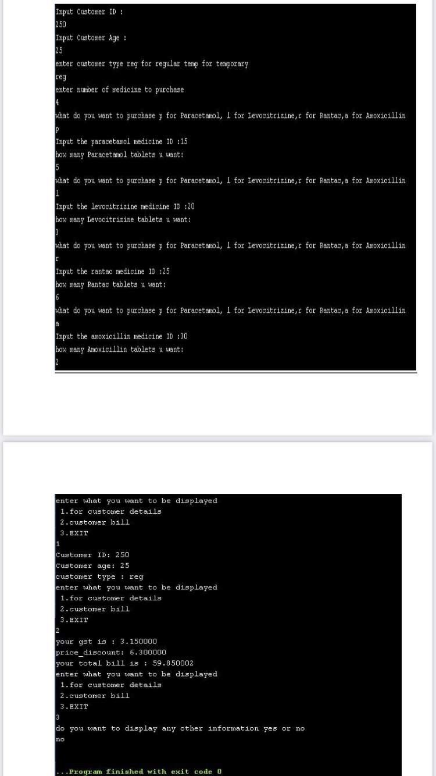

## Ex.No :3 Date:

**LOOPING**

**PROBLEM GIVEN**: Write a program to include an Exit Option by the user. The menu should be displayed, only if the user selects the option 4. Exit should the loop run. Use do while to implement the same. Extend the previous program to implement the program.

## ALGORITHM:

Cust_id = customer id  
custage = customer age  
medid = medicine id  
cust_type = customer type regular or temporary  
price = to store the total price of medicine  
gst = to add 5% fixed gst to price  
tot_amt = to store the total price after adding gst  
medicine_to_purchased= to store the medicine to be purchased.  
paracetamol_quantity= to store the quantity of paracetamol tablet  
levocitrizine_quantity= to store the quantity of levocitrizine tablet  
rantac_quantity= to store the quantity of rantac tablet  
amoxicillin_quantity= to store the quantity of amoxicillin tablet  
paracetamol_rate= fixed price of paracetamol tablet  
levocitrizine_rate= fixed price of levocitrizine tablet  
rantac_rate= fixed price of rantac tablet  
amoxicillin_rate= fixed price of amoxicillin tablet  
medicine_purchased= to the medicine purchased by customer  
price_discount= to calculate 10% discount of regular customer

STEP-1 = START

STEP-2 = Enter the value of custid ,custage

STEP-3 = Enter cust_type reg for Regular and temp for Temporary

STEP-4 = what type of medicine want to purchased  
 what do you want to purchase p for Paracetamol, l for Levocitrizine,  
 r for Rantac,a for Amoxicillin.

STEP-5=Enter the quantity of tablets you to purchase as per medicine selection

STEP-6 = for regular (10% discount)  
 price = c+d+e+f  
 gst = price*0.05  
 price_discount= (price*10)/100  
 tot_amt = price+gst-price_discount

STEP-7= for temporary  
 price = c+d+e+f  
 gst = price*0.05  
 tot_amt = price+gst-price_discount

STEP-8= switch(a)  
 case 1: customer details;  
 case 2: customer bill;  
 case 3: Exit;

STEP-9= Display information as per case selection

**FLOWCHART:**

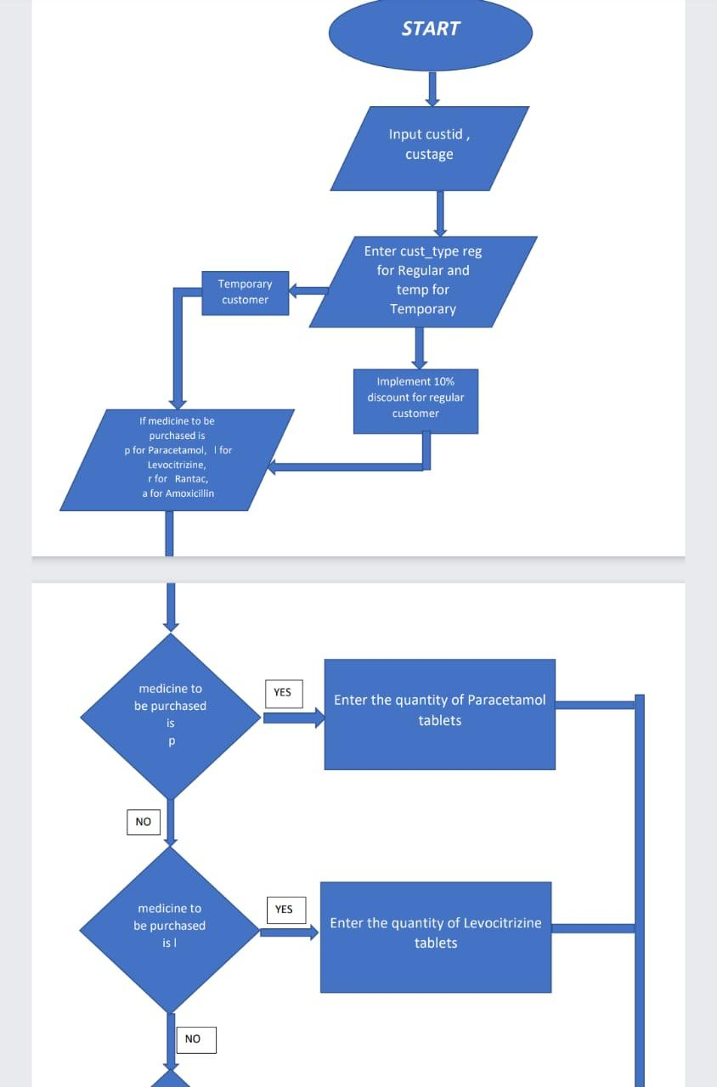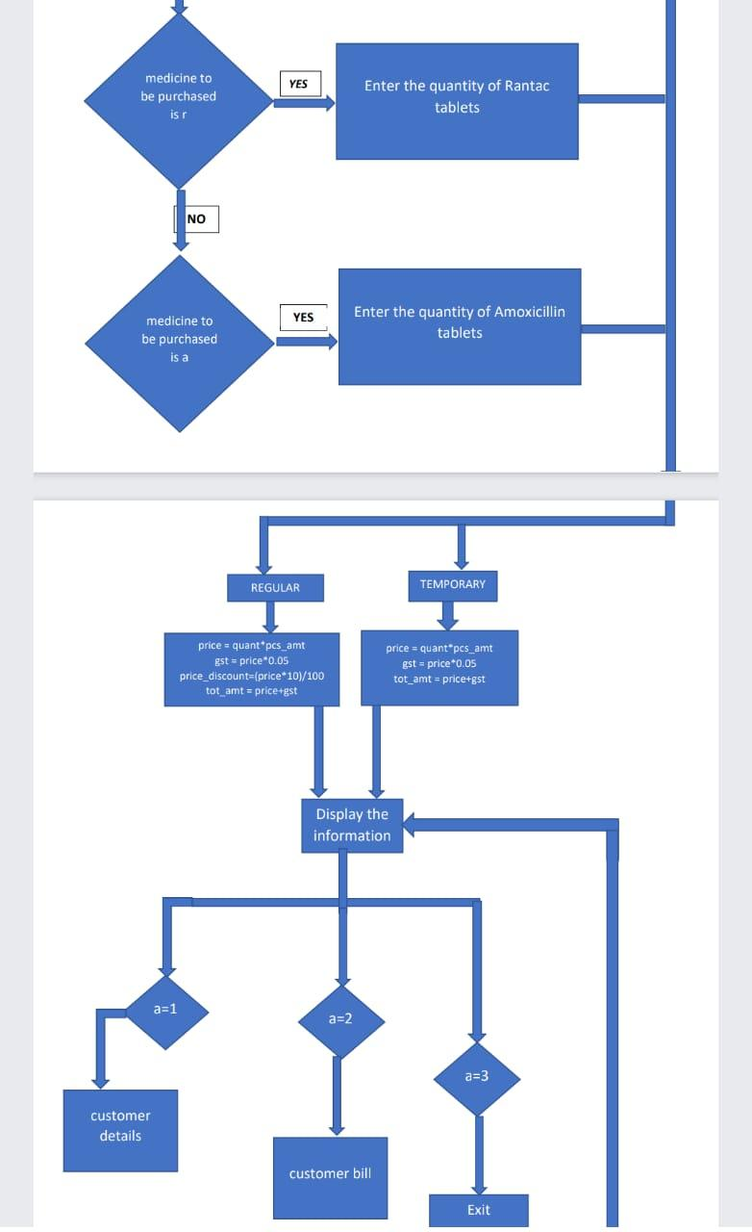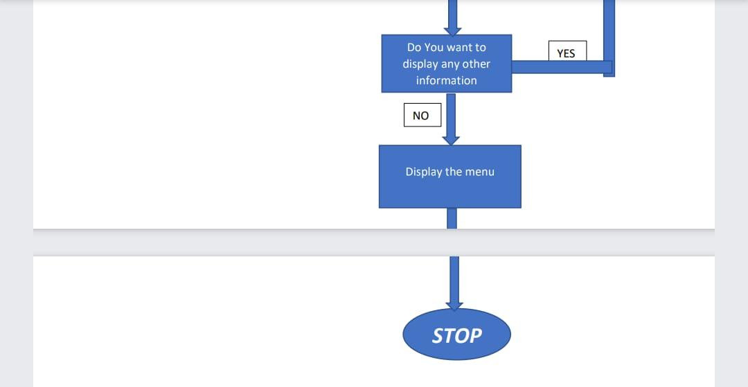

## PROGRAM:

**#include <stdio.h>  
#include <conio.h>  
#include <string.h>  
#include <math.h>  
void main()  
{   
 int custid,custage,medicine_to_purchase,i,a,h;  
 int paracetamol_quantity,levocitrizine_quantity,rantac_quantity,amoxicillin_quantity;  
 float paracetamol_rate = 5;// this rate is based per tablet   
 float levocitrizine_rate = 2;// this rate is based per tablet  
 float rantac_rate = 2;// this rate is based per tablet  
 float amoxicillin_rate = 10;// this rate is based per tablet  
 float price,gst,Tot_amt,price_discount;  
 char medicine_purchased[50];  
 char cust_type[50];  
 float c,d,e,f;  
 char opt[50];  
 printf("Input Customer ID :\n");  
 scanf(" %d",&custid);  
 printf("Input Customer Age : \n");  
 scanf(" %d",&custage);  
 printf("enter customer type reg for regular temp for temporary \n");  
 scanf("%s",&cust_type);  
 printf("enter number of medicine to purchase \n");  
 scanf("%d",&medicine_to_purchase);  
for ( i = 0; i < medicine_to_purchase; i++)  
{  
 printf("what do you want to purchase p for Paracetamol, l for Levocitrizine,r for Rantac,a for Amoxicillin \n");  
 scanf("%s",medicine_purchased);  
 if ((strcmp(medicine_purchased,"p") == 0)||(strcmp(medicine_purchased,"P") == 0))  
 {  
 printf("Input the paracetamol medicine ID :15 \n");  
 printf("how many Paracetamol tablets u want: \n");  
 scanf("%d",&paracetamol_quantity);   
 c=paracetamol_rate*paracetamol_quantity;  
 }**

**else if ((strcmp(medicine_purchased,"l") == 0)||(strcmp(medicine_purchased,"L") == 0))**

**{  
 printf("Input the levocitrizine medicine ID :20 \n");  
 printf("how many Levocitrizine tablets u want: \n");  
 scanf("%d",&levocitrizine_quantity);   
 d=levocitrizine_rate*levocitrizine_quantity;  
 }**

**if ((strcmp(medicine_purchased,"r") == 0)||(strcmp(medicine_purchased,"R") == 0))**

**{  
 printf("Input the rantac medicine ID :25 \n");  
 printf("how many Rantac tablets u want: \n");  
 scanf("%d",&rantac_quantity);  
 e=rantac_rate*rantac_quantity;   
 }**

**else if((strcmp(medicine_purchased,"a") == 0)||(strcmp(medicine_purchased,"A") == 0))**

**{  
 printf("Input the amoxicillin medicine ID :30 \n");  
 printf("how many Amoxicillin tablets u want: \n");  
 scanf("%d",&amoxicillin_quantity);   
 f=amoxicillin_rate*amoxicillin_quantity;   
 }**

**}**

**if (strcmp(cust_type,"reg") == 0 || strcmp(cust_type,"REG"))**

**{**

**price= c+d+e+f;  
 gst=price*0.05;  
 price_discount=(price*10)/100;  
 Tot_amt=price-price_discount+gst;  
}**

**else if (strcmp(cust_type,"temp") == 0 || strcmp(cust_type, "TEMP"))**

**{**

**price=c+d+e+f;  
 gst=price*0.05;  
 Tot_amt=price+gst;**

**}**

**do**

**{**

**printf("enter what you want to be displayed \n 1.for customer details\n 2.customer bill \n 3.EXIT\n");  
 scanf("%d",&a);  
 switch (a)**

**{**

**case 1:  
 printf("Customer ID: %d\n",custid);  
 printf("Customer age: %d\n",custage);  
 printf("customer type : %s\n", cust_type);  
 break;  
 case 2:  
 printf("your gst is : %f\n",gst);  
 printf("price_discount: %f\n",price_discount);  
 printf("your total bill is : %f\n",Tot_amt);  
 break;  
 case 3:  
 printf("do you want to display any other information yes or no \n");  
 scanf("%s",&opt);  
 if (strcmp(opt,"yes") == 0||strcmp(opt,"YES") ==0)  
 {  
 h=1;  
 }  
 else  
 {  
 printf("MENU :- \n");  
 printf("Customer ID: %d\n",custid);  
 printf("Customer age: %d\n",custage);**

**printf("customer type : %s\n", cust_type);  
 printf("your gst is : %f\n",gst);  
 printf("price_discount: %f\n",price_discount);  
 printf("your total bill is : %f\n",Tot_amt);  
 h=0;  
 }  
 }**

**} while (h>0);**

**getch();**

**}**

**OUTPUT:**

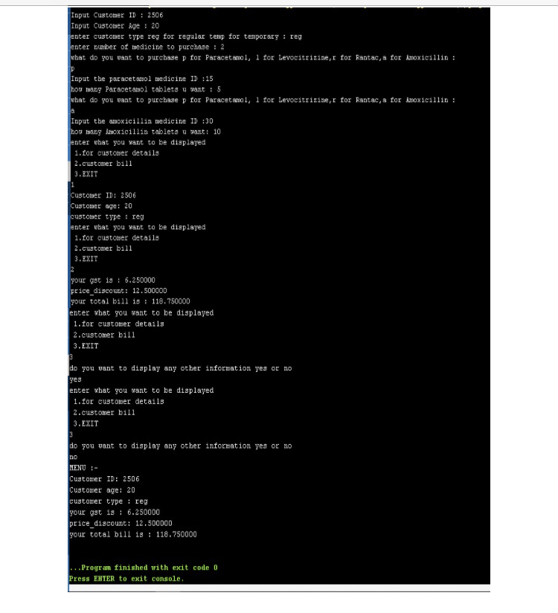

## Ex.No :4 Date:

**NESTED FOR LOOP**

**PROBLEM GIVEN**: Write a program in C to display the following patern  
  
+   
+ +  
+ + +  
+ + + +  
+ + + + +

## ALGORITHM:

## Rows= To Enter no. of Rows by user

## STEP-1 = START

## STEP-2 = Input number of rows STEP-3 = for ( i=1; i<=rows; i++) STEP-4 = for ( j=1; j<=i ; j++)

## inside the loop print (+)

## STEP-5 = output of the +pattern

## STEP-6 =STOP

## FLOWCHART:

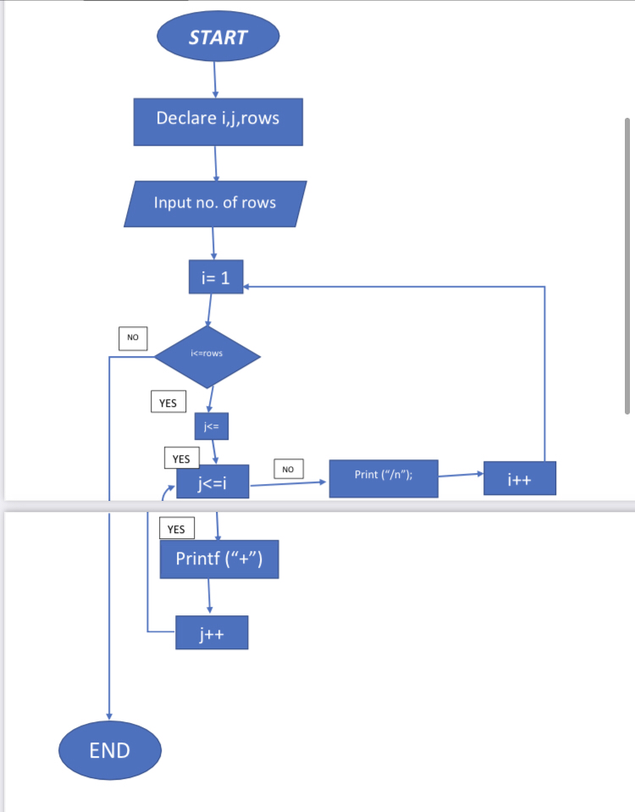

**PROGRAM:**

**#include <stdio.h>**

**int main()**

**{**

**int i,j,rows;**

**printf("Enter no of rows=");**

**scanf("%d",&rows);**

**for(i=1; i<=rows; i++)**

**{**

**for(j=1; j<=i; j++)**

**{**

**printf("+");**

**}**

**printf("\n");**

**}**

**return 0;**

**}**

**OUTPUT:**

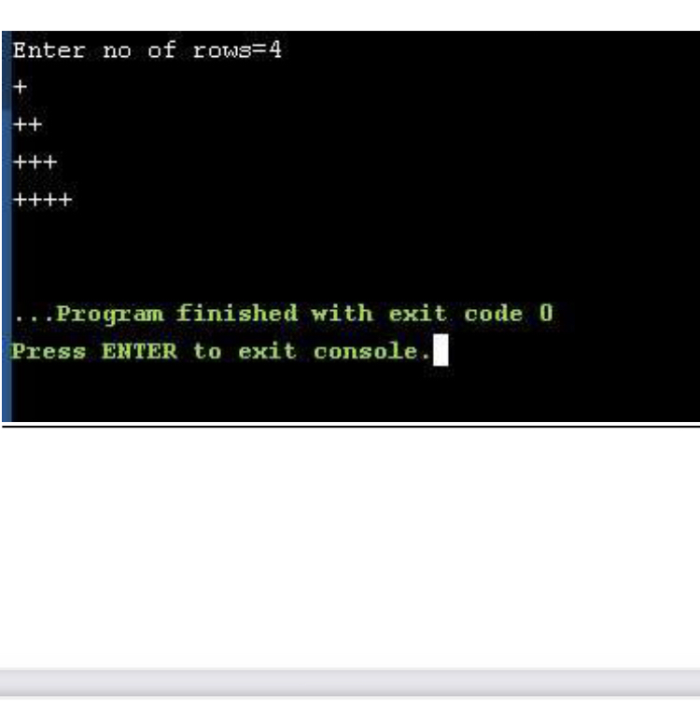

Ex.No :5 Date:

**1D ARRAY**

**PROBLEM GIVEN:** Write a program to implement arrays to store multiple patient details. Implement a logic to search for a patients details using binary search.

## ALGORITHM:

## STEP-1 = START

## STEP-2= int x

## Input opt,i,j,k,opt_2,H,n,m,opt_3,binary_search, first,last,middle,p,opt_4,z=2,H1,H3,H2

## STEP-3= do

## STEP-4= Menu

## 1.for entering data

## 2.for searching and displaying data 3.for exit

## STEP-5= switch(opt)

## case 1-Enter the number of customers

## STEP-6= do

## CUSTOMER DETAILS

## 1.for customer id 2.for customer name 3.for customer age 4.exit

## STEP-7=Switch(opt_2)

## 1.Enter all the customer id one by one

## for (j=0;j<n;j++)

## 2.Enter all the customer name one by one

## for (k=0;k<n;k++)

## 3.Enter all the customer age one by one

## for (H=0;H<n;H++)

## 4.Do you want to exit this menu

## 1.yes 2.no

## 5.Invalid option

## STEP-8=while(z>0)

## case 2-Enter the customer id you want to search the details

## first = 0

## last = n - 1

## middle = (first+last)/2 while (first <= last)

## STEP-9=Binarysearch

## if (cust_id[middle] < binary_search)

## first = middle + 1

## STEP10=elseif(cust_id[middle]==binary_search)

## STEP11=foundatlocation;binary_search,middle+1

## STEP-12=else

## last = middle – 1

## middle = (first + last)/2

## STEP-13=if(first>last)

## Not found

## STEP-14=case 3- do you want to exit

## 1.yes

2.no

STEP-15=while(x>0);

**STEEP-16 = stop**

**FLOWCHART:**

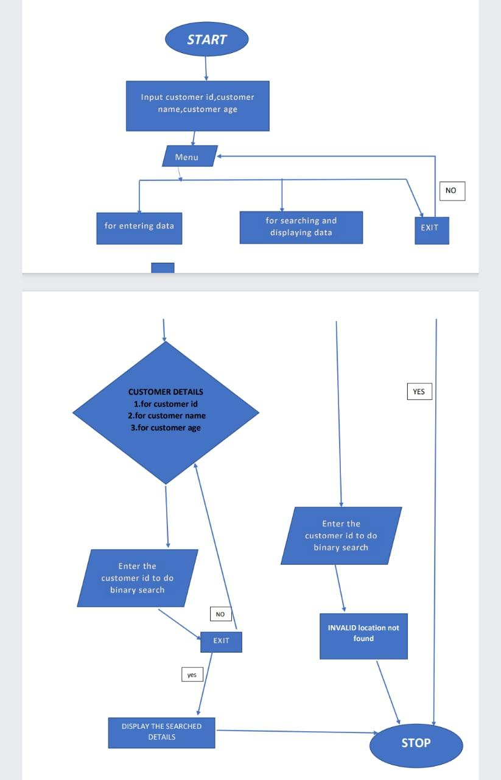

## PROGRAM:

## #include <stdio.h>

## #include <conio.h>

## #define maxsize 10000

## void main()

## {

## int x; do

## {

## int opt,i,j,k,opt_2,H,n,m,opt_3,binary_search; int first,last,middle,p,opt_4,z=2;

## int H1,H3;

## char H2;

## char cust_name[maxsize]; int cust_id[maxsize];

## int cust_age[maxsize];

## printf("\n MENU \n 1 for entering data \n 2 for searching and displaying the data \n 3 for exit \n");

## scanf("%d",&opt);

## switch (opt)

## {

## case 1:

## printf("Enter the number of CUSTOMER \n"); scanf("%d",&n);

## do {

## printf("\n CUSTOMER DETAILS \n 1.for customer id \n 2.for customer name \n 3.for customer age \n 4.Exit this location \n");

## scanf("%d",&opt_2); switch (opt_2)

## {

## case 1:

## printf("Enter all customer id one by one \n"); for ( j = 0; j < n; j++)

## {

## scanf("%d",&H1);

## cust_id[j]=H1; }

## break; case 2:

## printf("Enter all customer name one by one \n");

## for ( k = 0; k < n; k++) {

## scanf("%s",&H2); cust_name[k]=H2;

## }

## break; case 3:

## printf("Enter all customer age one by one \n"); for ( H = 0; H < n; H++)

## {

## scanf("%d",&H3); cust_age[H]=H3; }

## break; case 4:

## printf("Do you want to exit this menu\n 1.YES\n 2.No \n"); scanf("%d",&opt_3);

## if (opt_3==1)

## { z=0; } else

## {

## z=1;

## } break;

## default: printf("invalid option"); // default statements

## }

## }while(z>0); case 2:

## printf("Enter the customer id you want to search the details \n"); scanf("%d",&binary_search);

## first = 0;

## last = n - 1;

## middle = (first+last)/2;

## while (first <= last) {

## if (cust_id[middle] < binary_search)

## first = middle + 1;

## else if (cust_id[middle] == binary_search) {

## printf("%d found at location %d.\n", binary_search, middle+1); break;

## }

## else

## last = middle - 1;

## middle = (first + last)/2;

## }

## if (first > last)

## printf("Not found! %d not present in list.\n", binary_search); printf("\n the customer details are as follow: \n"); printf("customer id : %d\n",cust_id[middle]); printf("customer name: %c\n",cust_name[middle]); printf("customer age : %d\n",cust_age[middle]);

## break;

## case 3:

## printf("do you want to exit this program 1.yes 2.no \n"); scanf("%d",&opt_4);

## if (opt_4==1)

## {

## x=0; }

## else {

## x=1; }

## break;

## default: printf("invalid option");

## // default statements

## }

## } while (x>0);

## getch();

## }

**OUTPUT:**

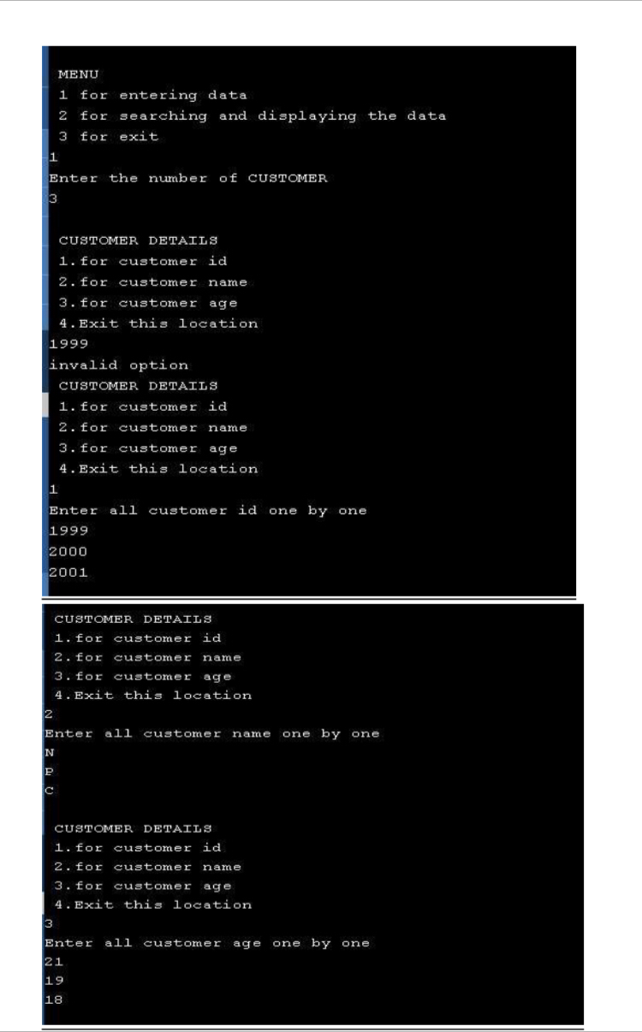

## Ex.No :6 Date:

**2D ARRAY**

**PROBLEM GIVEN**: Write a program to add two matrices

## ALGORITHM:

Step 1: start

Step 2: enter the elements of first matrix

Step 3: for (i=0;i<3;i++)

Step 4:for (j=0;j<3;j++)

Inside the loop scanf (“%d”,&a[i][j]

Step 5: enter the elements of second matrix

Step 6: for (i=0;i<3;i++)

Step 7:for (j=0;j<3;j++)

Inside the loop scanf (“%d”,&b[i][j])

Step 8: display first matrix

Step 9: display second matrix

Step 10:c[i][j]=a[i][j]+b[i][j]

Step 11: display sum of two matrices

Step 12: stop

**FLOWCHART:**

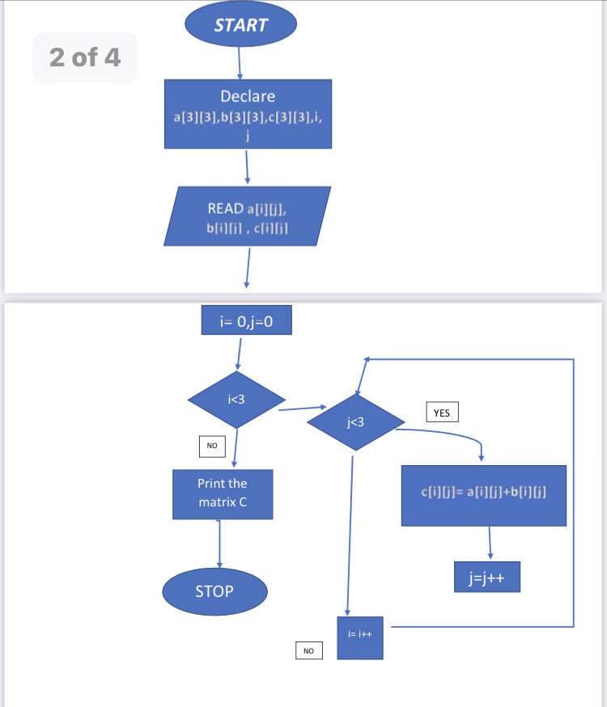

## PROGRAM:

 #include <stdio.h>

#include <stdlib.h>

 int main()

{

  int a[3][3],b[3][3],c[3][3],i, j;

printf("enter the 1st  matrix\n");

{

for(i=0;i<3;i++){

 for(j=0;j<3;j++){

  scanf("%d",&a[i][j]);

   }

}

}

printf("enter the 2nd  matrix\n");

{

for(i=0;i<3;i++){

 for(j=0;j<3;j++){

  scanf("%d",&b[i][j]);

 }

}

}

printf("the 1st is matix\n");

{

for(i=0;i<3;i++){

 for(j=0;j<3;j++){

  printf("%d\t",a[i][j]);

}

printf("\n");

}

}

printf("the second matrix is\n");

for(i=0;i<3;i++){

 for(j=0;j<3;j++){

printf("%d\t",b[i][j]);

}

printf("\n");

}

for(i=0;i<3;i++){

for(j=0;j<3;j++){

  c[i][j]=a[i][j] +b[i][j];

}

}

printf("the sum of two matrices is\n");

for(i=0;i<3;i++){

for(j=0;j<3;j++){

printf("%d\t",c[i][j]);

}

printf("\n");

}

return 0;

}

**OUTPUT:**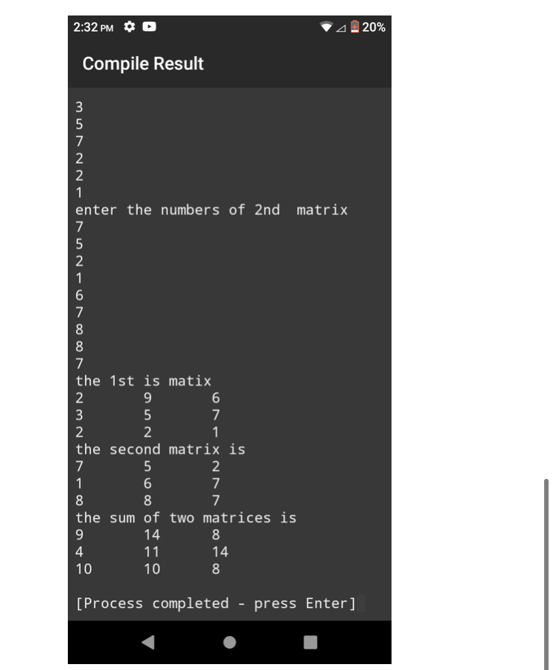

Ex.No :7 Date:

**POINTERS**

## PROBLEM GIVEN: Write a program to read n number of patient_ids and total bill paid (for in and out patients) into an array. Calculate the total amount spent a particular Patient and display the same in the form of Patient Account balance sheet. Implement the same using pointers.

## ALGORITHM:

**custid = to store customer id**

**custage = to store customer age**

**price = to store the price the medicine**

**n = number of customers**

**medicine_to_purchase = to store number of medicines**

**step 1: start**

**step 2: Enter the number of cutomers**

**step 3: for(i=0;i<n;i++)**

**step 4: enter customer id, customer age, customer type reg for regular and temp for temporary , price of medicine and quantity of medicine step 5: for regular 10% discount**

**step 6: amt[i] = price [i]*medicine_to_purchase[i]**

**gst[i] = amt[i]*0.05 discount[i] = (amt[i]*10)/100**

**Tot_amt[i] =amt[i]+gst[i] step 7: for(i=0;i<n;i++)**

**step 8: display customer id, customer age, customer type, gst, discount and**

**total bill**

**Step 9: p+**

**Step 10: stop**

**FLOW CHART:**

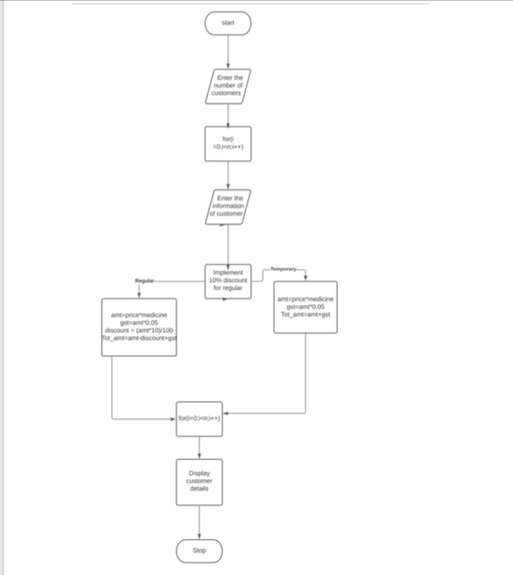

## PROGRAM:

## #include <stdio.h>

## #include <string.h>

## #define maxsize 10000

## void main()

## {

## int n,i,j,a,h;

## float *p1;

## 

## float custid[10000];

## int custage;

## float price[1000];

## float medicine_to_purchase[10];

## float amt[maxsize];

## float gst[1000];

## float Tot_amt[maxsize];

## float discount[maxsize];

## p1=&custid;

## char cust_type[50];

## 

## printf("enter number of customer \n");

## scanf("%d",&n);

## for( i=0;i<n;i++)

## {

## printf("Details of customer_ID %d\n", i+1);

## printf("Input Customer ID :\n");

## scanf(" %f",&custid[i]);

## printf("Input Customer Age : \n");

## scanf(" %d",&custage);

## printf("enter customer type reg for regular temp for temporary \n");

## scanf("%s",&cust_type[i]);

## printf("enter number of medicine to purchase \n");

## scanf("%f",&medicine_to_purchase[i]);

## printf("enter the price of medicine \n");

## scanf("%f",&price[i]);

## }

## for( i=0;i<n;i++)

## {

## if (strcmp(cust_type,"r") == 0 || strcmp(cust_type,"R"))

## {

## amt[i]=price[i]*medicine_to_purchase[i];

## gst[i]=amt[i]*0.05;

## discount[i]=(amt[i]*10)/100;

## Tot_amt[i]=amt[i]-discount[i]+gst[i];

## }

## else if (strcmp(cust_type,"t") == 0 || strcmp(cust_type, "T"))

## {

## amt[i]=price[i]*medicine_to_purchase[i];

## gst[i]=amt[i]*0.05;

## Tot_amt[i]=amt[i]+gst[i];

## }

## }

## for(j=0;j<n;j++)

## {

## printf("Customer ID: %f\n",*p1);

## printf("Customer age: %d\n",custage);

## printf("customer type : %s\n", cust_type);

## p1++;

## }

}

**OUTPUT:**

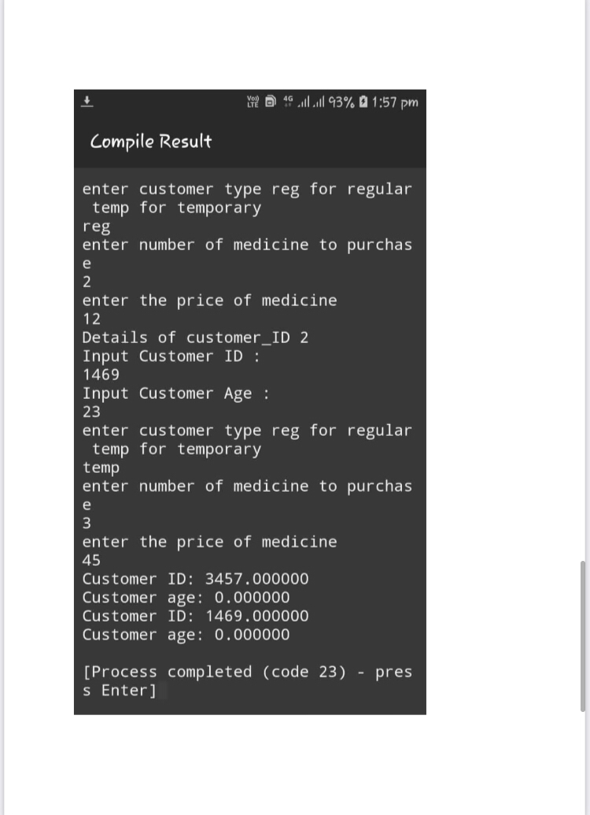

## Ex.No :8 Date:

**USER DEFINED FUNCTION**

## PROBLEM GIVEN: write a program to implement user defined functions to implement the following functionality 1. Patient details 2. Receipt Bill Generation 3. Patient Data collection

## ALGORITHM :

Declare variables

cust_details

{

int custid,custage,quant

char cust_type

float pcs_amt, price, gst, price_discount,Tot_amt

}

step 1: start

step 2: enter the details of the customer

step 3: if(customer type = reg)

           price = quant*pcs_amt

           gst = price*0.05

           price_discount =(price*10)/100

          Tot_amt = price – price_discount+gst

step 4: else if(customer type = temp)

            price = quant*pcs_amt

           gst = price*0.05

          Tot_amt = price – price_discount+gst

step 5: print the details of customer

step 6: stop

**FLOWCHART:**

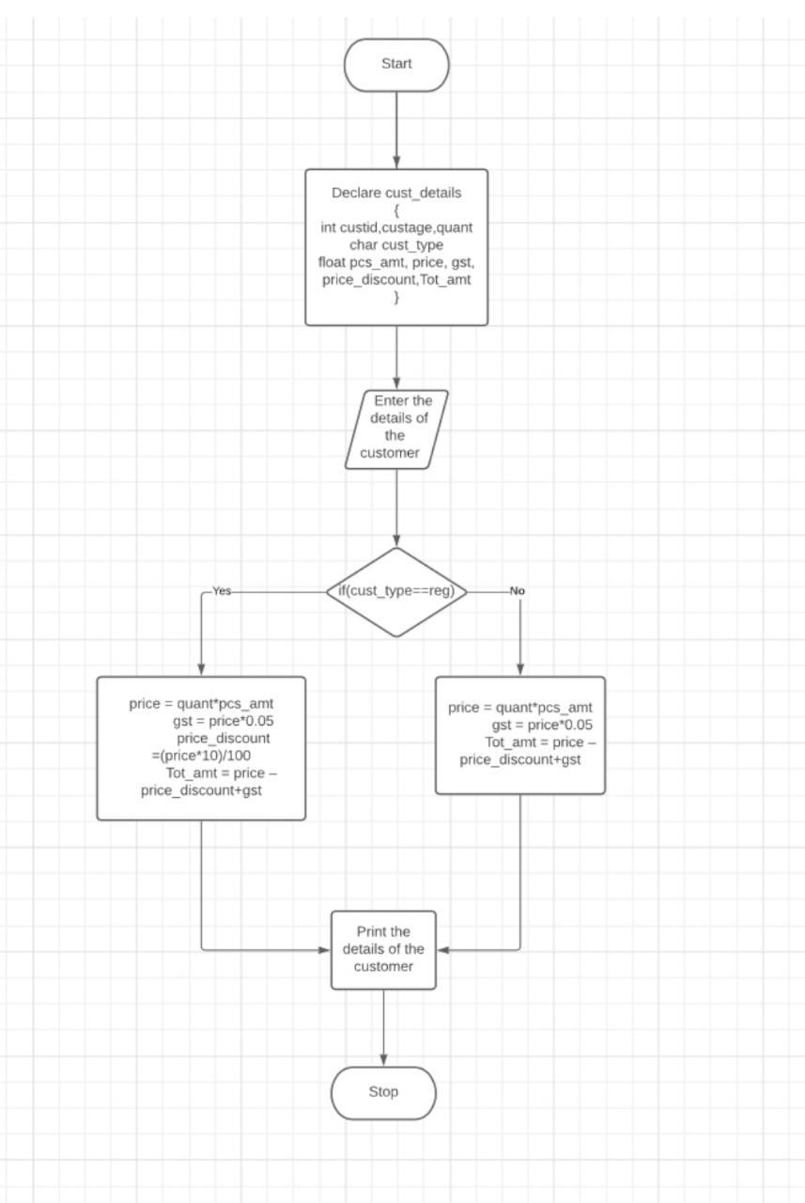

## PROGRAM:

**#include <stdio.h>**

**#include <string.h>**

**void cust_details();**

**void main()**

**{**

**cust_details();**

**return 0;**

**}**

**void cust_details()**

**{**

**int custid,custage,quant;**

**char cust_type[100];**

**float pcs_amt,price,Tot_amt,gst,price_discount;**

**printf("Input Customer ID :\n");**

**scanf(" %d",&custid);**

**printf("Input Customer Age : \n");**

**scanf(" %d",&custage);**

**printf("enter the quantity :\n");**

**scanf(" %d",&quant);**

**printf("enter the amount of 1medicine : \n");**

**scanf(" %f",&pcs_amt);**

**printf("Input the cust_type (r,t): \n");**

**scanf(" %d",&cust_type);**

**if (strcmp(cust_type,"r") == 0 || strcmp(cust_type,"R"))**

**{**

**price=quant*pcs_amt;**

**gst=price*0.05;**

**price_discount=(price*10)/100;**

**Tot_amt=price-price_discount+gst;**

**}**

**else if (strcmp(cust_type,"t") == 0 || strcmp(cust_type, "T"))**

**{**

**price=quant*pcs_amt;**

**gst=price*0.05;**

**Tot_amt=price+gst;**

**}**

**printf("Customer ID: %d\n",custid);**

**printf("Customer age: %d\n",custage);**

**printf("quantity: %d\n",quant);**

**printf("amount of 1 medicine: %f\n",pcs_amt);**

**printf("price: %f\n",price);**

**printf("total amount: %f\n",Tot_amt);**

**}**

**OUTPUT:**

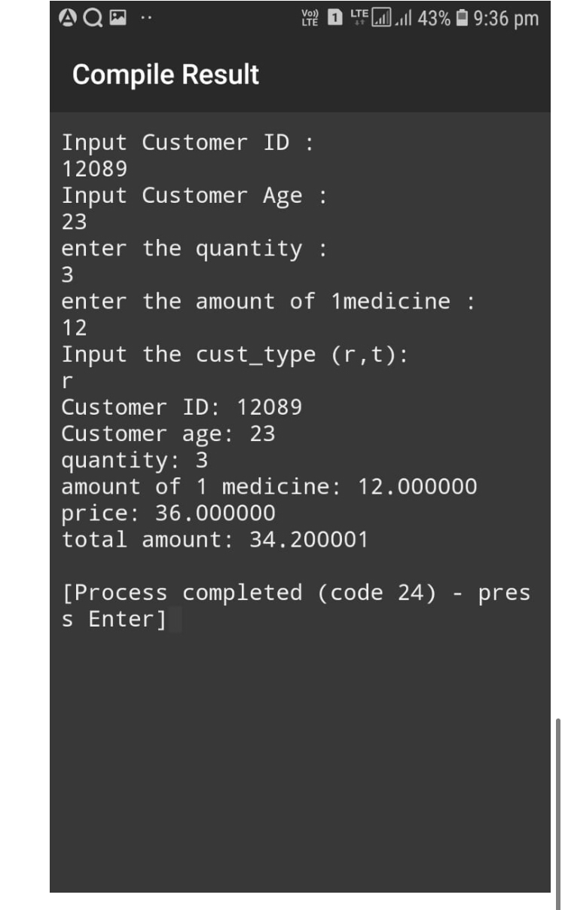

**Ex.No :9 Date:**

**STRUCTURES**

## PROBLEM GIVEN: Write a progam to create a structure for storing the patient details. Use appropriate data types to store the data (arrays, strings etc). Extend the previous program to implement the same.

**ALGORITHM:**

Declare variables

struct customer

{

int customer_id,p_age,quant;

float tot_amt,pcs_amt,gst,price_discount,price;

char c_type,c_name;

}

step 1: start

step 2 : enter the number of customers

step 3: for(i=0;i<n;i++)

step 4: enter the details of customer

step 5:if(cust_type==’R’)

step 6: p[i].price=p[i].pcs_amt*quant

p[i].gst=p[i].price*0.05

p[i]. price_discount=(p[i].price*10)/100

p[i].tot_amt=p[i]. price+p[i].gst-p[i]. price_discount

step 7: else if(cust_type==’T’)

p[i].price=p[i].pcs_amt*quant

p[i].gst=p[i].price*0.05

p[i].tot_amt=p[i]. price+p[i].gst

step 8: display patient details

step 9: Stop

**FLOWCHART:**

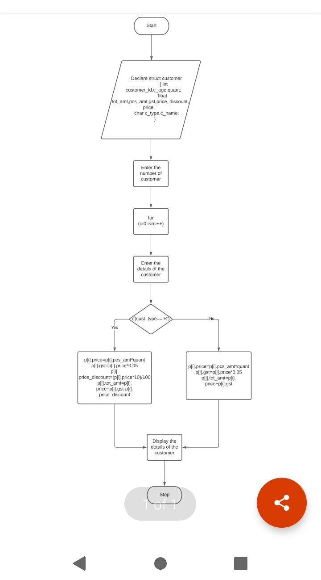

## PROGRAM:

## #include<stdio.h>

## struct customer

## {

## int cust_id,p_age,quant;

## float tot_amt,pcs_amt,gst,price_discount,price;

## char p_type,p_name;

## };

## int main()

## {

## int i,n;

## struct customer p[200];

## 

## printf ("Enter the no. of customer:\n");

## scanf ("%d", &n);

## for ( i = 0; i < n; i++)

## {

## printf("Enter the customer ID :-\n");

## scanf("%d",&p[i].cust_id);

## printf("Enter the customer type(R=regular,T=temporary):-\n");

## scanf("%s",&p[i].p_type);

## printf("Enter the customer name :-\n");

## scanf("%s",&p[i].p_name);

## printf("Enter the customer age :-\n");

## scanf("%d",&p[i].p_age);

## printf("enter the no. of tablet\n");

## scanf("%d",&p[i].quant);

## printf("enter the price of 1 tablet \n");

## scanf("%f",&p[i].pcs_amt);

## }

## for ( i = 0; i < n; i++)

## {

## if(p[i].p_type=='R')

## {

## p[i].price=p[i].quant*p[i].pcs_amt;

## p[i].gst=p[i].price*0.05;

## p[i].price_discount=(p[i].price*10)/100;

## p[i].tot_amt=p[i].price-p[i].price_discount+p[i].gst;

## }

## else if (p[i].p_type=='T')

## {

## p[i].price=p[i].quant*p[i].pcs_amt;

## p[i].gst=p[i].price*0.05;

## p[i].tot_amt=p[i].price+p[i].gst;

## }

## }

## printf("CUSTOMER DETAILS\n");

## for ( i = 0; i < n; i++)

## {

## printf("customer ID: %d\n",p[i].cust_id);

## printf("customer type: %c\n",p[i].p_type);

## printf("customer NAME: %c\n",p[i].p_name);

## printf("customer AGE: %d\n",p[i].p_age);

## printf("quantity: %d\n",p[i].quant);

## printf("amount of 1 medicine: %f\n",p[i].pcs_amt);

## printf("price: %f\n",p[i].price);

## printf("total amount: %f\n",p[i].tot_amt);

## }

## return 0;

## }

**OUTPUT:**

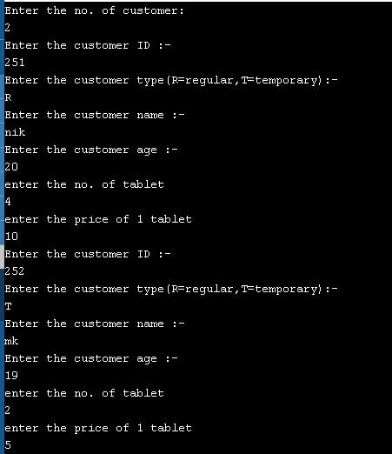

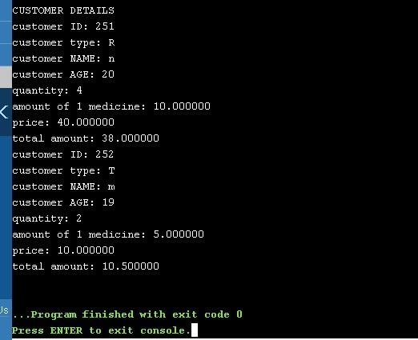

**Ex.No :10 Date:**

**FILES**

## PROBLEM GIVEN: Write a program to store the patient data into a file and extract data based on the users requirement

## ALGORITHM:

Declare variables

char con [100], yn

FILE *fptr, FILE *fptr2

int size, i, Total

step 1: start

step 2: struct customer

            int customer_id, age, weight, bill, medicine

            char customer_type[30]

step 3: enter the number of customers

step 4: struct customer arr[size]

            struct customer *ptr

step 6: fptr=fopen

step 7: if(fptr== NULL)

            no file exists

step 8: for(i=0;i<size;i++)

            enter the details of customer

            Total+=arr[i].bill;

             ptr=arr;

             ptr++;

step 9: do you want to extract the patient details from the file(Y/N)

step 10: if (yn==’Y’)

               fptr2=fopen

step 11: if (fptr2==NULL)

             file doesnot exist

            else

            print the details of customer

step 12: stop

**FLOWCHART:**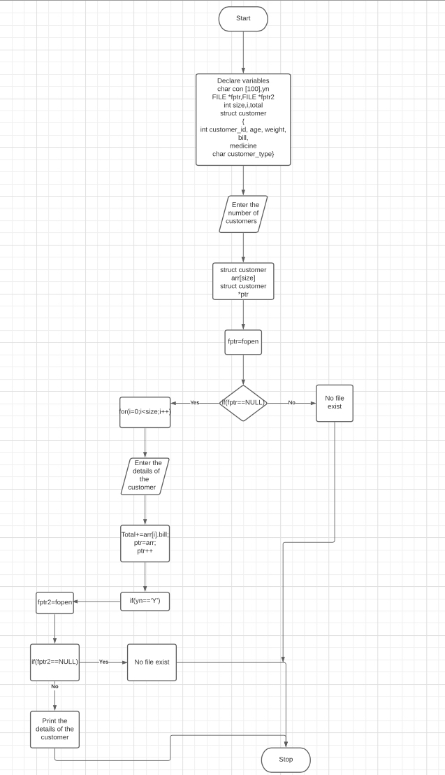

## PROGRAM:

**#include <stdio.h>**

**#include <stdlib.h>**

**struct customer**

**{**

**int customer_id,age,weight,bill,medicine;**

**char customer_type[30] ;**

**};**

**int main()**

**{**

**char con[100];**

**char yn;**

**FILE *fptr;**

**FILE *fptr2;**

**int size,i,Total=0;**

**printf("Enter no.of customer :");**

**scanf("%d",&size);**

**struct customer arr[size];**

**struct customer *ptr;**

**fptr=fopen("D:\christ.txt","w");**

**if (fptr == NULL)**

**{**

**printf("File does not exists \n");**

**return 1;**

**}**

**for(i=0;i<size;i++)**

**{**

**printf("Enter customer id :");**

**scanf(" %d",&arr[i].customer_id);**

**printf("Enter age :");**

**scanf(" %d",&arr[i].age);**

**printf("Enter weight :");**

**scanf(" %d",&arr[i].weight);**

**printf("Enter customer type :");**

**scanf(" %s",&arr[i].customer_type);**

**printf("enter number of medicines:");**

**scanf("%d",&arr[i].medicine);**

**printf("Enter bill paid by the customer:");**

**scanf(" %d",&arr[i].bill);**

**}**

**for (i=0;i<size;i++)**

**{**

**Total+=arr[i].bill;**

**}**

**ptr=arr;**

**for (i=0;i<size;i++)**

**{**

**fprintf(fptr,"customer %d \n customer id :%d\n age :%d\n weight :%d\n customer type :%s\n number of medicine : %d\n bill paid :%d\n\n",i,ptr->customer_id,ptr->age,ptr->weight,ptr->customer_type,ptr->medicine,ptr->bill);**

**ptr++;**

**}**

**fprintf(fptr,"Total Amount received by the pharmacy :%d",Total);**

**fclose(fptr);**

**printf("Do you want to extract the patient details from file(Y/N) :");**

**scanf(" %c",&yn);**

**if(yn=='Y')**

**{**

**fptr2=fopen("D:\christ.txt","r");**

**if (fptr2 == NULL)**

**{**

**printf("File does not exists \n");**

**return 1;**

**}**

**while (fgets(con, 1000, fptr2) != NULL)**

**printf("%s",con);**

**fclose(fptr2);**

**}**

**else**

**return 0;**

**}**

**OUTPUT:**

